CREATE TABLE Items(
itemid NUMBER PRIMARY KEY,
itemname VARCHAR2(50),
category VARCHAR2(50),
price NUMBER,
instock NUMBER CHECK (instock >= 0)
);
INSERT INTO Items VALUES (1,'Samsung GalaxyS4','Mobile',6500,13);
INSERT INTO Items VALUES (2,'lenovo Laptop','Electronics',75000,5);
INSERT INTO Items VALUES (3,'Headphones','Accessories',3500,10);
INSERT INTO Items VALUES (4,'redmi12','Mobile',12000,7);
INSERT INTO Items VALUES (5,'acer desktop','Electronics',24000,4);
select * from Items;
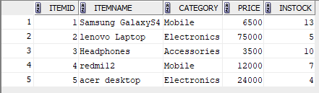
CREATE TABLE Customerss ( custid NUMBER PRIMARY KEY,custname VARCHAR2(53),address VARCHAR2(110), state VARCHAR2(50));
INSERT INTO Customers VALUES (1,'Jeena','pala','kerala');
INSERT INTO Customers VALUES (2,'Mickey','panaji','goa');
INSERT INTO Customers VALUES (3,'Jison','patna','bihar');
INSERT INTO Customers VALUES (4,'Jensen','riyadh','dubai');
INSERT INTO Customers VALUES (5,'Dona','kozhikode','kerala');
select * from Customers;
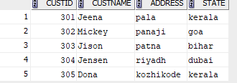

CREATE TABLE Orders_25 (orderid NUMBER PRIMARY KEY, itemid NUMBER, custid NUMBER,quantity NUMBER, orderdate DATE,
FOREIGN KEY (itemid) REFERENCES Items(itemid),FOREIGN KEY (custid) REFERENCES Customerss(custid));
INSERT INTO Orders_25 VALUES (101,1,301,2,'21-11-2014');
INSERT INTO Orders_25 VALUES (102,2,302,1,'23-11-2016');
INSERT INTO Orders_25 VALUES (103,3,303,3,'31-03-2017');
INSERT INTO Orders_25 VALUES (104,4,304,1,'21-10-2014');
INSERT INTO Orders_25 VALUES (105,5,305,2,'31-01-2015');
select * from Orders_25;
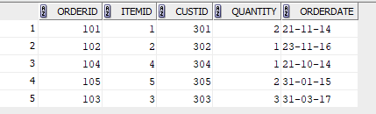
INSERT INTO Delivery VALUES (5001,301,101);
SELECT DISTINCT c.*
FROM Customers c
JOIN Orders o ON c.custid = o.custid
JOIN Delivery d ON o.orderid = d.orderid;
INSERT INTO Delivery VALUES (5002,302,102);
INSERT INTO Delivery VALUES (5003,303,103);
select * from delivery;
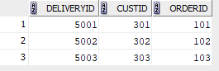
1. List the details of all customers who have placed an order
SELECT DISTINCT c.*
FROM Customerss c
JOIN Orders_25 o ON c.custid = o.custid;
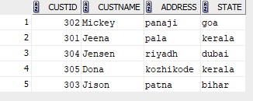
2. List the details of all customers whose orders have been delivered
SELECT DISTINCT c.*
FROM Customerss c
JOIN Orders_25 o ON c.custid = o.custid
JOIN Delivery d ON o.orderid = d.orderid;
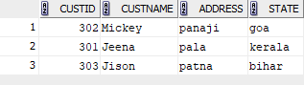
3. Find the order date for all customers whose name starts in the letter‘J’
SELECT o.orderdate
FROM Orders_25 o
JOIN Customerss c ON o.custid = c.custid
WHERE c.custname LIKE 'J%';
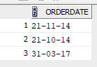
4. Display the name and price of all items bought by the customer‘Mickey’
SELECT i.itemname, i.price
FROM Items i
JOIN Orders o ON i.itemid = o.itemid
JOIN Customers c ON o.custid = c.custid
WHERE c.custname = 'Mickey';
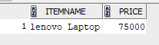
5. List the details of all customers who have placed an order after January 2013 and not received delivery of items
SELECT DISTINCT c.*
FROM Customerss c
JOIN Orders_25 o ON c.custid = o.custid
LEFT JOIN Delivery d ON o.orderid = d.orderid
WHERE o.orderdate > '31-01-2013'
AND d.deliveryid IS NULL;
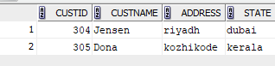
6 Find the itemid of items which has either been ordered or not delivered. (UseSET UNION)
SELECT itemid
FROM Orders
UNION
SELECT o.itemid
FROM Orders o
JOIN Delivery d ON o.orderid = d.orderid
WHERE d.deliveryid IS NULL;
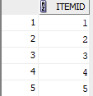
7 Find the name of all customers who have placed an order and have their ordersSELECT custname
FROM Customers
WHERE custid IN (
SELECT custid FROM Orders
)
INTERSECT
SELECT custname
FROM Customers
WHERE custid IN (
SELECT o.custid
FROM Orders o
JOIN Delivery d ON o.orderid = d.orderid
);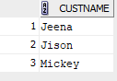
8. Find the custname of all customers who have placed an order but not having their orders delivered. (Use SET MINUS) delivered.(Use SET INTERSECTION)

